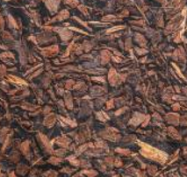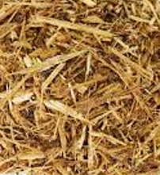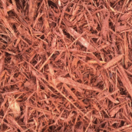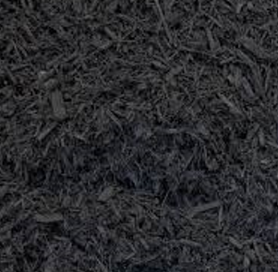
Spring has sprung...time to tend to your yard!
Seminole Band Mulch Fundraiser!

Natural Cypress - $5.00 per 2 cu ft bag
Red Mulch - $4.50 per 2 cu ft bag
Black Mulch - $4.50 per 2 cu ft bag
Pine Bark Nuggets -$5.00 per 2 cu ft bag

Order online at seminoleband.org
Need assistance? Email: seminolewarhawkband@gmail.com
or call/text 336-263-0658
Delivery Date-April 17th
Free Delivery with an order of 5 bags or more!!

Boost your home’s curb appeal AND support your Warhawk Band Program!

